**Projectile Weapon and Object Pool Scripts**

First each projectile weapon needs to be equipped with the GunShoot.cs script. As shown below the script can be used on multiple types of projectile weapons, including automatic fire and grenades.

Gun shot Distance is how far the projectile can go before its destroyed.

Gun Shot Rate is the amount of bullets per step.

Gun Shot Speed is the initial speed of the bullet.

Bullet Max Number is the amount of bullets to use before recycling(for performance).

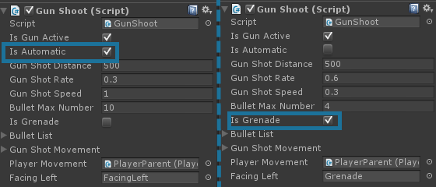

Each projectile is stored in Bullet List, and the corresponding projectile scripts stored in Gun Shot Movement list. This script handles movement of the projectile. It can be used for grenades or bullets as shown below. The grenade is handled different than the bullets, it uses force vectors and a rigid body to control the grenade. These values can be tweaked for desired angle. 